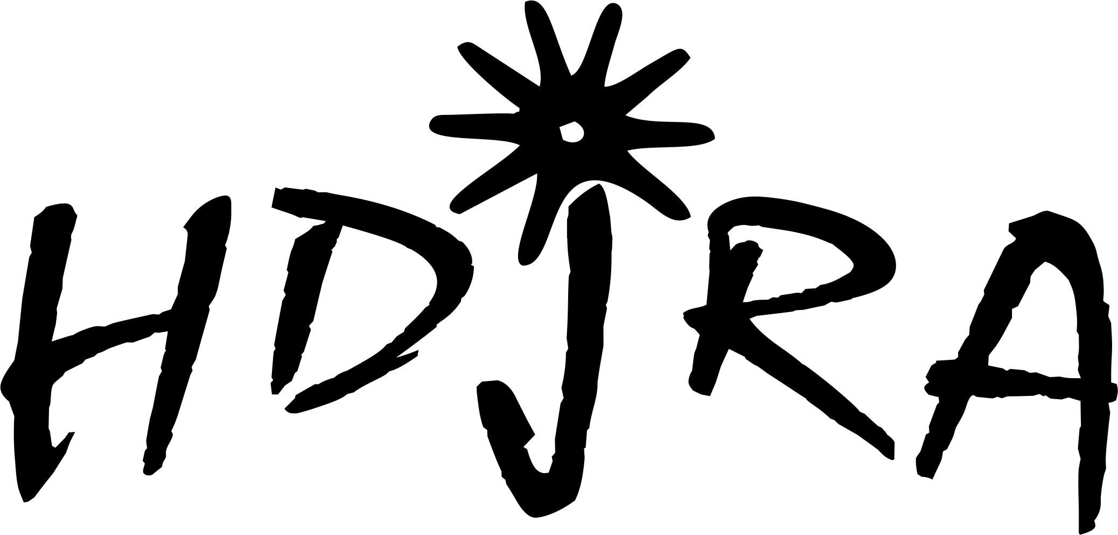

Dear Potential HDjRA Award Sponsor:

How our program works: Cowboys & Cowgirls compete in one or our three age divisions for year end points that are earned at our sanctioned rodeos throughout the seasons. In each division the boys and girls compete separately. We award 7 all around saddle to the high point winning Cowboy and Cowgirl in each division as well reserve All Around awards for each age division. Each age division competes in events and we award a custom made buckle to the high point winner of each event for each age division. We set a goal this year to provide awards through fourth place and the funding for these prizes comes from a number of sources~arena fees, a variety of fund raisers that we hold throughout the year, and from private sponsorships. We are asking you to please take a look at the following sponsorship levels and consider helping us reach our goals for these young rodeo contestants.

Level | Description | Amount
1 | One trophy saddle: We award 6 of these saddles to the high point cowboy and cowgirl from each age division. | $1500
2 | A package that sponsors the Reserve All Around award in each of the specific age divisions. | $500
3 | Sponsor one custom made buckle to give as a first place award in one of our events. | $150
4 | Sponsor one 2nd place award. | $100
5 | Sponsor one 3rd place award. | $75
5 | Sponsor one 4th place award. | $50

All sponsors receive recognition for their level of donation at all HDjRA sponsored events. This includes recognition throughout the rodeos, logos printed on our daysheets, Facebook posts, and your logo will also go on the HDjRA website.

We appreciate your willingness to consider supporting junior rodeo and the young people that compete. Our association promotes sportsmanship, responsibility, hard-work, and willingness to learn and promotes a good healthy family atmosphere. We hope you will choose to support our fundraising effort by filling out the enclosed form and sending it back as soon as possible.

THANK YOU FOR YOUR CONSIDERATION!
HDjRA Year End Award Sponsorship Form

Company Name:
Contact Person:
Mailing Address:
Phone Number:
Fax Number:
Email Address:
Website:
Special Instructions or Requests for acknowledgement
Member’s Name
requesting donation

Please select the level of award sponsorship from the list below: Level: ______

Level | Description | Amount
1 | One trophy saddle: We award 6 of these saddles to the high point cowboy and cowgirl from each age division. | $1500
2 | A package that sponsors the Reserve All Around award in each of the specific age divisions. | $500
3 | Sponsor one custom made buckle to give as a first place award in one of our events. | $150
4 | Sponsor one 2nd place award. | $100
5 | Sponsor one 3rd place award. | $75
5 | Sponsor one 4th place award. | $50

Please send your donation to HDjRA Secretary:
C/O Lindsay Brice
315 S 341 Ln W
Heyburn ID 83336

The High Desert Junior Rodeo Association is a non-profit organization committed and dedicated to promoting Idaho youth in the sport of rodeo. The HDjRA strives to build interest understanding and appreciation for the Western life, sportsmanship and family involvement as well as holding all of its active members to high academic standards.

The success of our organization is highly dependent upon sponsorships in addition to membership fees. Your donation is greatly appreciated and is TAX DEDUCTIBLE.

The sponsorship levels are attached, and we hope we can count on your support for such a worthwhile cause and look forward to your participation. If you are unable to find a level that meets your needs and would prefer to make a monetary contribution, please make check payable to HDjRA and send to:

HDjRA
C/O Lindsay Brice
315 S 341 Ln W
Heyburn ID 83336

If you have any questions or would like more information, please contact, Lindsay Brice, at 208-312-9141, or Tiffany Hartman 702-353-9130.

Thank you for your consideration!

Sincerely,
Lindsay Brice and Tiffany Hartman
High Desert Junior Rodeo Association

